**More about isolated areas**

* Roughly isolated area is analogues to vm, but major difference is VMs have a full blow os whereas isolated areas (containers) don’t have a full blow os.
* Since they don’t have full blown os,
  + CPU and other resources are allocated to application rather than os
  + This reduces the overhead of OS Patching
  + Savings on cost as containers on license costs 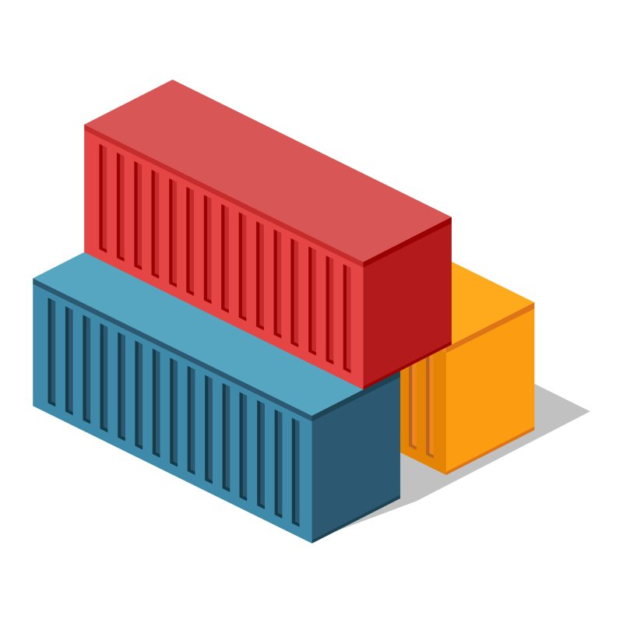
* Every container (isolate area) gets
  + CPU
  + RAM
  + Storage
  + Network (ip address)
* We will be using docker to create these isolated areas called as containers.
* Docker is British expression for Dock Worker who is responsible for loading and unloading container in the shipyard 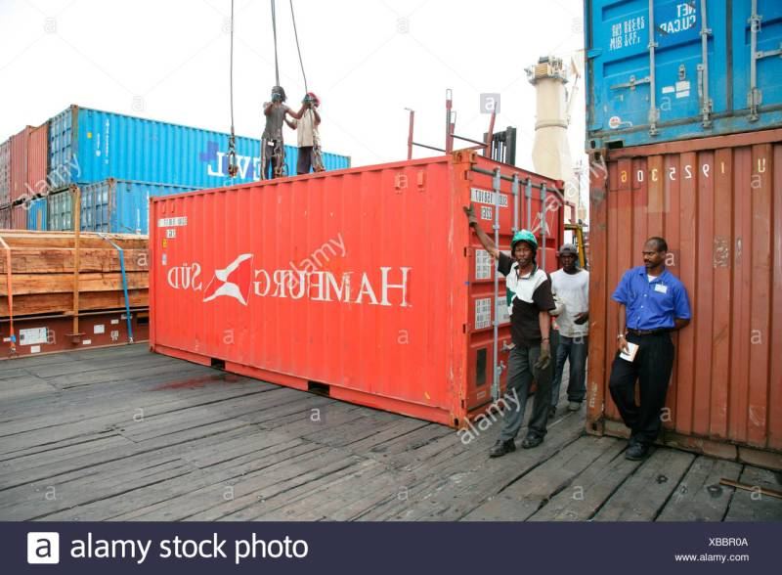

**Intro to Linux Containers**

* Modern container started in the Linux world and are product of immense contributions for over a period of time from organizations such as Google LLC
* Some of the major technologies in Linux which contributed to massive growth of containers are
  + kernel namespaces
  + control groups
  + union filesystems
  + Docker

**Windows Containers**

* Microsoft corp has worked along with Docker to bring container technologies to Windows Platform
* Windows Container can be created on
  + Window 10 (Non Home editions)
  + Windows Server 2016 and Later
* Microsoft had changed the core Window Kernel to implement Containers.

**Docker Technology**

* When we install docker, we have the following components installed into our machine
  + docker client
  + docker daemon (engine)
* Login into docker playground create an instance and execute docker version

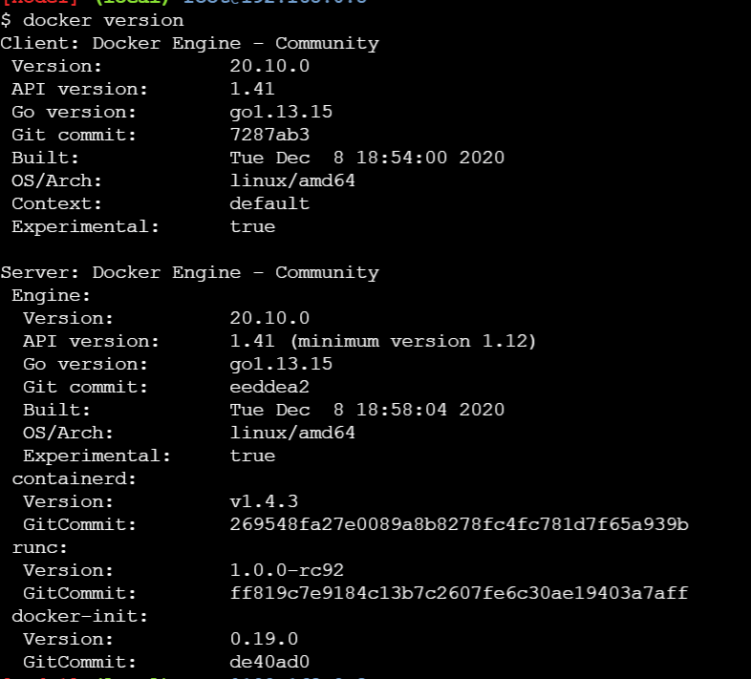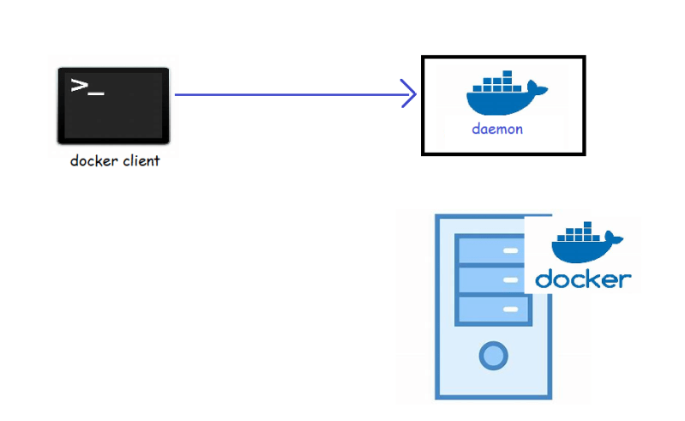

* Let’s try to create one container:
  + from docker client we need to specify we need a container
  + let’s use a simple image called as hello-world
* To run a docker container we need a docker image. Docker has hub which hosts lots of images 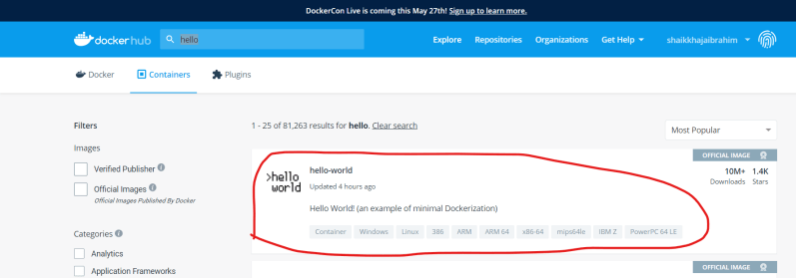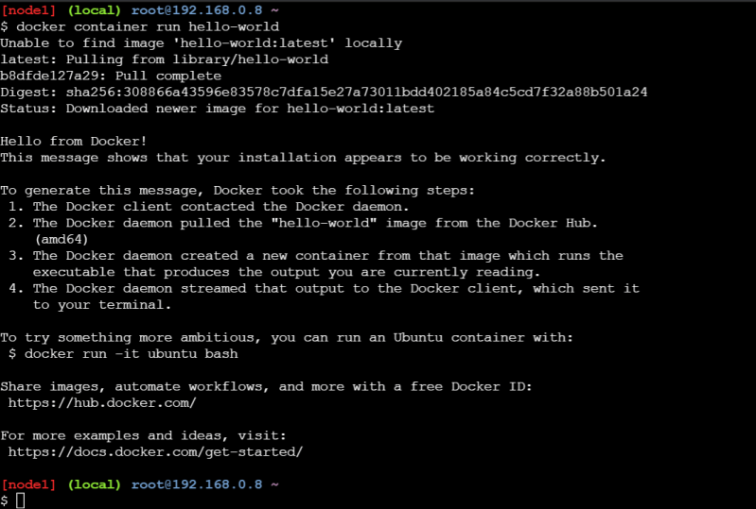
* Now let’s summarize the steps 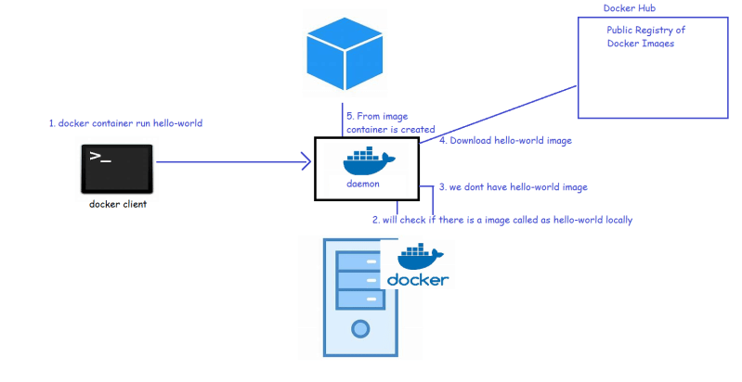
* Now lets try to create one more container with hello-world 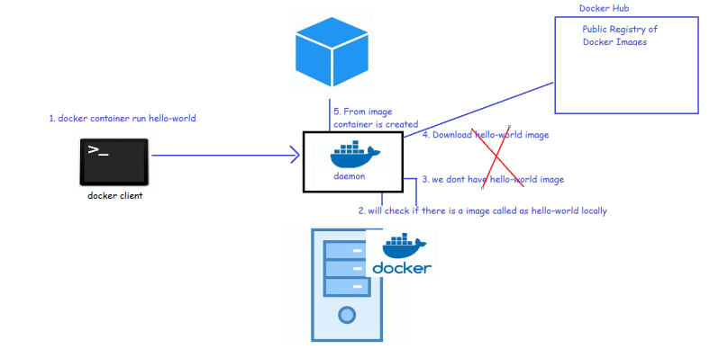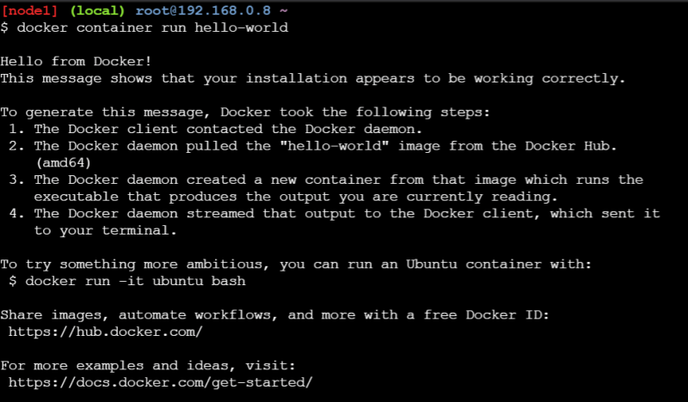
* So, to create container we need images. In reality in container we would want to run our applications developed
* So, we need to create images with our applications in it to create containers
* So, the first task for us is to understand how to create images so that we can run our applications
* Terminology: In case of Docker we will be packaging our applications as Docker images.

Why name Docker? Docker is a British word meaning “a person employed in a port to load and unload ships”